kmNof; lgb]{lzsf

Flash Manual

Flash Software xfNg rflxg] Go"gtd cfjZostfx? M

1. **Windows XP,** jf ;f] eGbf dflysf **Windows** x? .
2. CD jf Pen Drive leq /x]sf] Flash software, of] software ;Fu ;lDalGwt **Update** kmfOnx? .
3. lhNnfsf] **database file** .

**Flash Software klxn] g} xfn]sf] 5 ls 5}g egL s;/L yfxf kfpg] <**

1. of] yfxf kfpg Windows XP df eP Programs df hfg] / Flash n]v]sf] Software 5 ls 5}g x]g]{ . Windows 7 df eP All Programs df hfg] Flash n]v]sf] Software 5 ls 5}g x]g]{ . cyjf C Drive sf] Program Files leq Flash eGg] Folder 5 ls 5}g x]g]{ .

**klxn] Flash Software xfn]sf] 5}g eg] s;/L xfNg] <**

1. tkfO{;Fu ;L=8L jf k]g 8«fOe leq /x]sf] Flash Software nfO{ Double click ug]{ . o;f] ubf{ tn b]lvPsf] h:tf] Box cfpFb5 . ca Next df Click ug]{ .

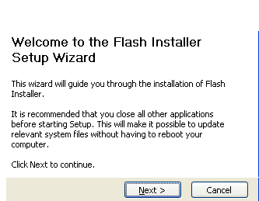

|  |
| --- |
| ;km6\j]o/ **Install** ubf{ Wofg lbg'kg]{ dxTjk"0f{ s'/fM  Computer sf] Configuration cg';f/ Flash Software install x'g'eGbf clw jf x'g] qmddf Block, Unblock jf Allow, Deny eGg] s'/fx? ;f]Wg ;S5 . To:tf] cj:yfdf Unblock jf Allow df click ug]{ . |

1. ca Software sxfF Save ug]{ eg]/ ;f]W5 . olb tkfO{nfO{ ToxFf b]vfPsf] eGbf cnu 7fpFdf Save ug{ dg nfU5 eg] Tof] 7fpF select ug]{ gq eg] Install Click ug]{ .

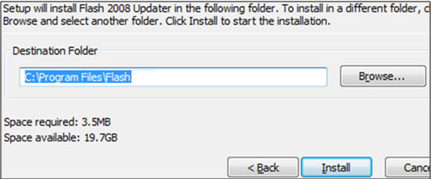

1. olt ul/;s]kl5 Finish df click ug]{ .

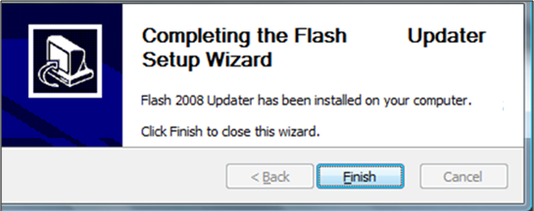

**klxn] g} Flash Software xfn]sf] 5 eg] s] ug]{ <**

1. olb klxn] g} Flash Software xfln;s]sf] 5 eg] / ;f] Software rln/x]sf] 5 eg] km]/L Software xfln/fVg' kb}{g . Software rn]sf] 5 jf 5}g eg]/ x]g{ Flash sf] kmf/fdnfO{ Flash Software df ePsf] kmf/fd;Fu ldnfP/ x]g]{ . olb ldN5 eg] tkfO{sf] Computer df ePsf] Flash Software Latest xf], x}g eg] tkfO{;Fu CD jf Pen Drive leq /x]sf] Flash Update Install u/] k'Ub5 . of] Update Install ug{ dfly b]vfOPsf] h:t} u/L tkfO{;Fu ePsf] Flash Update nfO{ Double Click ug]{, Next df Click ug]{, Install df Click ug]{ / ;lsPkl5 Finish ug]{ .

|  |
| --- |
| **Update Install** ubf{ Wofg lbg'kg]{ dxTjk"0f{ s'/fM  Flash Software hFxf Install u/]sf] 5 Flash Update klg ToxL Install ug'{kg]{5 . pbfx/0fsf] nflu dfly lbOPsf] lrqdf Flash Software C drive sf] Program Files sf] Flash eGg] Folder df Install ul/Psf] 5 . o;}sf/0f Flash Update klg ;f]xL 7fpFdf g} Install ug'{kg]{5 . |

**klxn] Flash Software xfln;s]sf]] 5 t/ ;f] Software rn]sf] 5}g eg] Flash Software s;/L xfNg] <**

1. olb klxn] g} Flash Software xfln;s]sf] 5 t/ Software rln/x]sf] 5}g eg] Flash Software nfO{ ;a}eGbf klxn] x6fpg'kb{5 . o;sf nflu C drive leq, Program Files leq, Flash eGg] Folder vf]Ng] . ToxfF Uninstall eGg] Icon 5, To;nfO{ Click ug]{ . tn afFof efudf b]lvPsf] h:tf] Box cfPkl5 Uninstall df Click ug]{ .

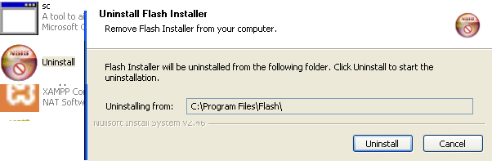

1. olt ul/;s]kl5 km]l/ C drive leq, Program Files leq hfg] / Flash eGg] Folder nfO{ g} Delete ul/lbg] . Delete ug{ dfg]g eg] Computer Restart u/]/ Delete ul/lbg] . of] gul/sg km]l/ Flash Software xfNg vf]Hbf slxn] sfFxL ;d:of cfpFg ;Sb5 .
2. olt ul/;s]kl5 dfly elgPsf] h:t} u/L Flash Software xfn] x'G5 .

**Flash Software s;/L rnfpg] <**

1. Flash Software xfln;s]kl5 Computer sf] Desktop df Flash eGg] Icon cfpFb5 . olb Desktop df ;f] Icon 5}g eg] Start df Programs df hfg] / Flash eGg] Icon nfO{ Double Click ug]{ .
2. olt ul/;s]kl5 Flash Software sf] Year Set ug]{ . olb Computer sf] Date ;xL 5 eg] tn b]vfO{Psf] ldlt klg ;xL eP/ cfpFb5, gq eg] km/s km/s cfpFb5 . Flash Data Entry ug'{eGbf klxn] of] ldlt ;xL 5 ls 5}g eg]/ Confirm ug'{kb{5 . tn lbOPsf] ldlt 2068/2069 eGgfn] 2068 sf] Flash II / 2069 sf] Flash I eGg] a'emfpFb5 . 2069 sf] Flash II / 2070 sf] Flash I Entry ubf{ tn lbOPsf] Box df 2069/2070 x'g'kb{5 .

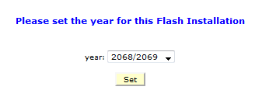

1. Year Set ul/;s]kl5 cfkm'x?nfO{ dg nfu]sf] Username / Password n]Vg] . Password xfNbf b'j} 7fpFdf Pp6} xfNg] .

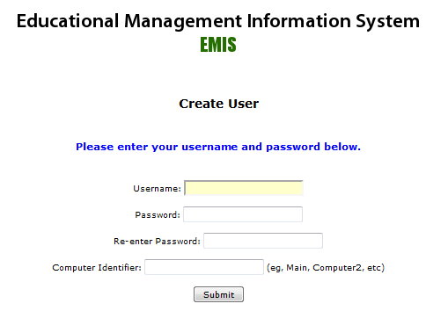

1. Computer Identifier eg]sf] 7fpFdf Computer sf] gfd xfNg] . Ps eGbf a9L Computer df Flash Data Entry ug]{ xf] eg] of] gfd ;a} Computer sf] km/s km/s x'g'kb{5 . ;a}eGbf ;lhnf]sf] nflu Comp1, Comp2 cflb eg]/ gfd lbFbf ;a}eGbf a]z x'G5 . gfd Ps} kbf{ slxn]sfFxL Data hf]8\bf ;d:of cfpg ;Sb5 .
2. olt ul/;s]kl5 tn b]lvP h:t} u/L km]/L Username / Password ;f]W5 . clw h] Username / Password /fv]sf] lyof] ToxL g} 6fOk ug]{ . Password save ug{ dg nfu] remember me df Click ug]{ . olt ul/;s]kl5 Login df click ug]{ .



|  |
| --- |
| gf]6M of] r/0f;Dd cfOk'Ubf aLr aLrdf Continue jf Cancel eg]/ ;f]Wbf Continue df Click ug]{ . |

1. Login df Click ul/;s]kl5 tn b]lvPsf] h:tf] Box cfpFb5 . oxfF;Dd k'Ubf Flash Software Install eO;s]sf] x'G5 t/ lhNnfsf] tYof+s eg] xfNg afFsL ePsf] x'G5 . lhNnfsf] tYof+s xfNg jf Import ug{ ;a}eGbf klxn] tkfO{sf] ;L=8L= jf k]g 8«fOeleq /x]sf] Database File nfO{ ;lhnf]sf nflu Desktop df Copy u/]/ /fVg] . Database file lagf Flash df s]xL klg sfd gx'g] ePsf]n] of] kmfOn Psbd} ;'/lIft;fy /fVg'kg]{5 . of] zip u/]/ /fv]sf] x'G5 .

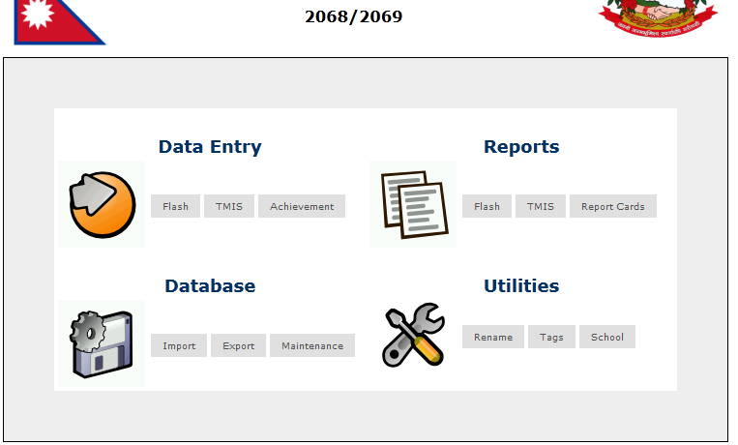

1. Desktop df skL u/]/ /fv]sf] Database nfO{ Flash Software df Import ug{ Database df ePsf] Import df Click ug]{ . olt ul/;s]kl5 Browse df Click ug]{ . tn b]vfOPsf] h:tf] u/L Box cfpFb5 . Desktop df ePsf] Database nfO{ Select ug]{, Open df Click ug]{ / Import df Click ug]{ . Database ;xL 5 eg] Data Import x'G5 / Flash Software df Entry ug{ ;lsG5 . Data Import ubf{ Zip u/]sf] jf gu/]sf] h'g};'s} File nfO{ Import ubf{ klg x'G5 .

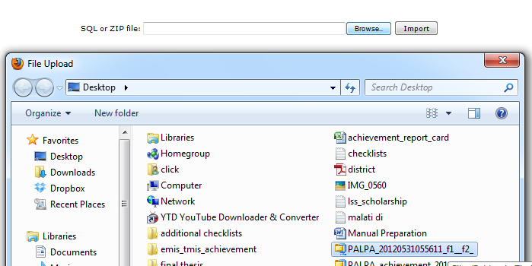

1. cfkm\gf] lhNnfsf] Database Import ul/;s]kl5 ca Flash Software df Data Entry ug{ jf Report x]g{ jf cGo s] ug{ rfx]sf] xf] ;f] ug{ ;lsG5 .

**Flash Software df Entry s;/L ug]{ <**

1. Flash Software sf] klxnf] efudf Data Entry 5 h;df Flash I, Flash II, TMIS / Achivement 5g\ . cfkm"nfO{ s'g rflxF Entry ug'{kg]{ xf] ;f]xL cg';f/ Click ug]{ . dfly lbOPsf] 2068/2069 eGgfn] 2068 sf] Flash II / 2069 sf] Flash I hgfpFb5 . of] ;fn k|To]s jif{ km/s km/s x'G5 .



1. dfgf} 2068 sf] Flash II eg'{k/]df dflysf] lrqdf b]vfOPsf] Data Entry sf] Flash df Mouse nu]/ /fVg] / Flash II df Click ug]{ . olt ul/;s]kl5 tn b]vfOP cg';f/sf] Box cfpFb5 .

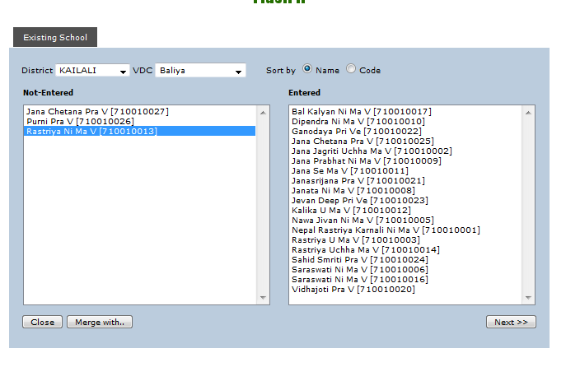

1. Data Entry gu?Gh]n lhNnfsf] uflj;ut ljBfnox?sf] gfdgfd];L afofFk§L b]lvG5 . Data Entry ul/;s]kl5 eg] ljBfnox?sf] gfd bfoFfk§L b]lvg yfNb5 . dflysf] pbfx/0fdf # j6f ljBfnox? afx]s cGo ;a} ljBfnox?sf] Flash II Entry eO{;s]sf] 5 .
2. ljBfnox?sf] gfdgfd];LnfO{ olt Name af6 Sort ug'{k/]df Sort By df Name df Click ug]{, olb Code af6 Sort ug{ k/]df Code df Click ug]{ .
3. ca s'g rflxF ljBfnosf] Data Entry ug]{ xf] ;f] ljBfno 5fGg] / Next df Click ug]{ .

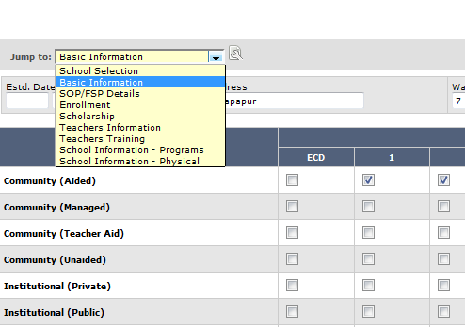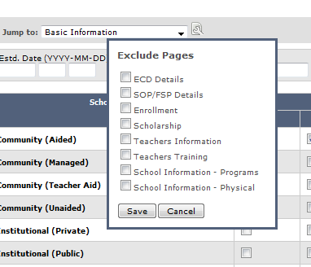

1. Next df Click ul/;s]kl5 ljBfnosf] ljljw hfgsf/L nufot ljBfnosf] k|sf/ / ljBfnodf rn]sf sIffx?af/] hfgsf/L kmf/fd cfpFb5 . dfly afofFk§L Jump To: eGg] Button 5 / clns k/ Notebook h:tf] Pp6f Icon 5 . tL Buttons x?df Click ubf{ dfly b]vfOPsf] h:tf] lrq cfpFb5 . ljBfnodf rn]sf] sIff cg';f/ of] Buttons x? km/s km/s x'G5 . hlt ljBfnosf] tx a9\b} hfG5 Tolt of] Buttons x? a9\b} hfG5 .
2. s'g} Ps jf ;f] eGbf w]/} kfgfx? 5f]8]/ csf]{ kfgf eg'{k/]df Jump To af6 kfgfx? Select ug{] . pbfx/0fsf] nflu ljBfnosf] k|sf/ el/;s]kl5 Ps}rf]l6 ljBfyL{ egf{sf] kmf/fd eg'{'k–of] / aLrsf] SOP/FSP Details eg'{kg]{ cj:yf 5}g eg] ;f]em} Enrollment df Click ul/lbg] .
3. s'g} ljBfnodf Ps eGbf a9L ECD x? ;+rfng ePsf] eP ECD Details df ECD #1 ;Fu} ePsf] Save & New ECD df hlt j6f ECD x? xf] ;f]xL cg';f/ yKb} hfg] . ECD x6fpg' kg]{ cj:yfdf Delete This ECD df Click ug]{ . tn b]vfOPsf] Box df Autofill eGg] Button klg 5 . o;af6 clwNnf] jif{sf] Data x? ;a} o;jif{df Nofpg ;lsG5 . pbfx/0fsf] nflu ECD Established Year clwNnf] ;fn 2056 eg]/ e/]sf] lyof] eg] ;f]xL tYofFs oxL jif{ klg ebf{ Autofill u/\of] eg] ;f] c+s tn b]vfOPsf] Established Year eGg] Box df cfpFb5 . h'g tYofFsx? k|To]s jif{ kl/jt{g e}/fVb}gg\ To;tf tYofFsx?df Autofill /flvPsf] 5 .

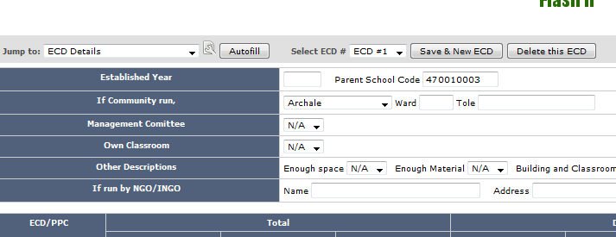

1. kmNof;sf] kmf/fd ebf{ k|To]s kfgfsf] d'lglt/ tn b]vfOP cg';f/sf] Buttons x? x'G5g\ . s'g} kfgfsf] kmf/fd el/;s]/ Next df Click ubf{ ;f] kfgfsf Data x? cfkm;]cfkm Save x'G5g\ t/ Entry ub}{ hfFbf Save (Ctrl+++S) klg u/]sf] 5}g / Next df klg Click u/]sf] 5}g eg] sy+sbflrt s'g} sf/0f Software aGb eof] eg] -dfgf}+ aQL uof]_ Data x? Save x'b}gg\ . o;}sf/0f s]xL Data Entry ug]{ljlQs} Save df Click ug]{ jf Ctrl+S lyRg] . kmNof; ebf{ s'g} kfgfaf6 Ps}rf]l6 Main Menu df hfg dg nfu] tn b]vfP cg';f/sf] Save & Add New df Click ug]{ .   
     
   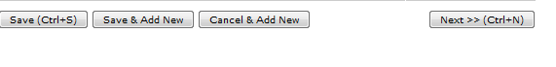
2. tn b]lvPsf] h:tf] kfgfx?df, pbfx/0fsf] nflu ljBfno ;'wf/ of]hgf ag]sf] 5 ls 5}g eGg] k|Zgdf Yes df Click ul/;s]kl5 c? Buttons x? b]lvG5g\ . o:tf] cj:yfdf Yes eg]/ kmf/fd el/of] eg] ;f]xL cg';f/sf cGo Buttons x? cfpFb5g\, No eg]/ el/of] eg] ;f]xL cg';f/sf kmf/fdx? cfpFb5g\ . o;df Psbd} ofb /fVg'kg]{ s'/f s] xf] eg] No / N/A df ePsf] leGgtf . pbfx/0fsf] nflu ljBfno ;'wf/ of]hgf ag]sf] 5 ls 5}g eg]/ tn ;f]lwPsf] Box df No elgof] eg] ljBfno ;'wf/ of]hgf ag]sf] 5}g /x]5 eGg] yfxf x'G5 . olb N/A eg]/ el/of] eg] yfxf 5}g eGg] pQ/ ldNb5 .

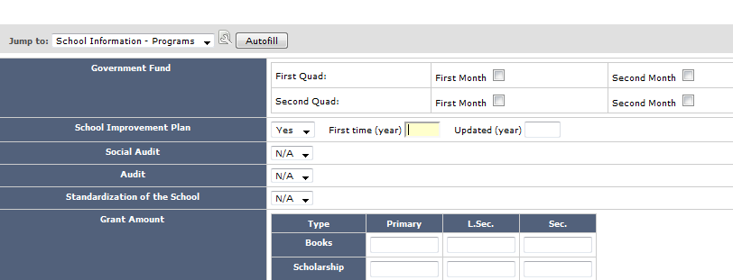

1. Flash I sf] Entry ubf{ klxnf] kfgfdf tn b]lvP h:tf] tYofFsx? Entry ug]{ 7fpF cfpFb5 . o;df ofb ug'{kg]{ s'/f] s] xf] eg] ljBfno olb !) sIff rn]sf] 5 eg\ SLC Board Code df Entry ug{ ldN5 gq ldNb}g . sIff !! rn]sf] 5 eg] HSEB COE df Entry ug{ ldNb5 . SLC Board Code xfNbf % c+ssf] sf]8 x'g'kb{5 eg] HSEB Code eg] $ c+ssf] x'g'kb{5 .

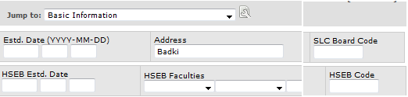

1. Flash I sf] Entry ubf{ School Select ug]{ kfgfdf tn k§L d'lg b]vfOPsf] h:tf] Box 5 . of] Box af6 ljBfno;Fu ;DalGwt Photos x? /fVg ;lsG5 . o;f] ug{ Browse df Click ug]{ h;kZrft Photo sxfF 5 eg]/ ;f]Wb5, To;kl5 Photo Select ug]{ / Open df Click ul/lbg] . tn b]vfOPsf] Description df kmf]6f];Fu ;DalGwt hfgsf/L n]lvlbg] / Add Photo df Click ug]{ . ca Flash I sf] ;f] kfgfdf cl3 xfn]sf] Photo klg cfpFb5 .

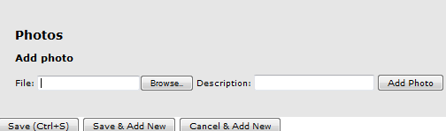

kmf]6f] x6fpg'k/]df Delete df Click ul/lbg klg ;lsG5 . Flash Software df ljBfnosf] kmf]6f] /fVg] sfd Flash I af6 dfq ;Dej 5 .

**Flash Software df ljBfno aGb ug]{ jf ljBfno ufEg] t/Lsf .**

1. ljBfno aGb x'Fbf jf Pp6f ljBfno csf]{ ljBfnodf ufleFbf Flash Software af6 g} Close jf Merge ug]{ . of] sfd eg] Flash II af6 dfq} ug{ ;lsG5 . o;sf nflu Flash II vf]Ng] . ljBfno aGb ePsf] xsdf xf] eg] s'g ljBfno aGb ePsf] xf] ;f] ljBfnonfO{ Select ug]{ / Close df click ug]{ . olt ul/;s]kl5 Do You Want To Close eg]/ ;f]Wb5 / ljBfno aGb ePsf] xf] eg] OK df Click ug]{ . olt ul/;s]kl5 aGb ePsf] ljBfnosf] gfd sfl6P/ bflxg] k§L cfpFb5 . ljBfno aGb ubf{ ljBfnosf] gfd Not-Entered df x'g' clQ cfjZos 5 . ljBfno aGb u/]sf] eGgfn] ljBfnosf] gfd Database af6 x6fpg] eg]sf] rflxF xf]Og .

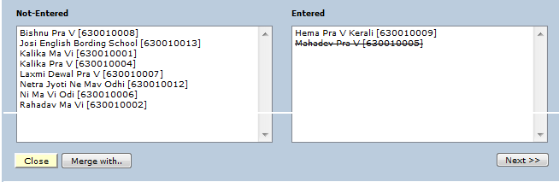

1. Pp6f ljBfno csf]{ ljBfnodf uflePsf] xsdf eg] Pp6f ljBfnosf] gfd Entered df / csf]{ ljBfnosf] gfd Not-Entered df x'g'kb{5 . ofg] ufleFg vf]lhPsf] ljBfnosf] gfd Not-Entered df / rln/x]sf] ljBfnosf] gfd Entered df x'g'kb{5 . ljBfno ufEg ca Not-Entered df ePsf] ljBfnosf] gfd Select ug]{ / Merge With df Click ug]{, Now Select School To Merge With Under Entered Schools List eg]/ Pp6f Box cfpFb5, OK df Click ug]{ / Entered df ePsf] ljBfnonfO{ Select ug]{ . pbfx/0fsf] nflu A eGg] ljBfno B ;Fu ufleFof] eg] klxn] B sf] tYofFs eg]{ / A sf] tYofFs geg]{ . ca B nfO{ Select ug]{ / Merge With df Click ug]{ / Entered af6 A nfO{ Select ug]{ . olt ul/;s]kl5 A / B eGg] ljBfnox? ufleG5g\ .

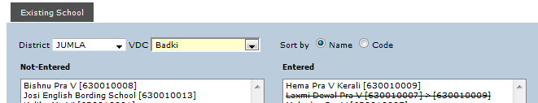

uflePsf] ljBfnosf] gfdgfd];L dfly b]vfOPsf] lrq h:t} b]lvG5 . Pp6f uflj;af6 csf]{ uflj;df ljBfnox? uflePsf] 5 eg] dfly b]lvPsf] t/Lsfaf6 ljBfnox? ufEg ;lsb}g . o:tf] cj:yfdf gofF ljBfnosf] ?kdf Flash Entry u/fpg] afx]s cGo ljsNk 5}g .

**Flash Software df gofF ljBfno Entry ug]{ t/Lsf .**

1. s'g} z}lIfs ;qdf gofF ljBfno btf{ ePsf] 5 eg] ;f]sf nflu Flash I af6 dfq} gofF ljBfno btf{ ug{ ;lsG5, Flash II af6 ;lsb}g . o;sf nflu Flash I df hfg], New School df Click ug]{, ljBfnosf] gfd, 7]ufgf / cGo hfgsf/Lx? eg]{ . ljBfnosf] sf]8 g++ eg] Flash Software n] cfkm} xfNb5 . o;/L sf]8 xfNbf uflj;df ePsf ljBfnox?sf] sf]8 x]/L s'g rflxF sf]8 vfnL 5, jf clGtd ljBfnosf] sf]8 kl5sf] sf]8 xfNb5 . pbfx/0fsf] nflu Abc eGg] uflj;df 1, 2, 4, 5 ljBfno sf]8x? ePsf ljBfnox? 5g\ eg] gofF ljBfnosf] xsdf olb b'O{j6f ljBfnox? Entry ePdf ;a}eGbf klxn] 3 g+ sf] sf]8 xfNb5 / bf]>f]sf] xsdf ^ g+= sf] sf]8 xfNb5 .

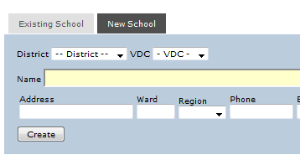

cfkm" :jo+n] sf]8 xfNbf ;d:ofx? cfpg] x'Fbf Flash Software n] g} sf]8 xfNg] Joj:yf ldnfOPsf] xf] .

**Flash Software df Reports x]g]{ t/Lsf .**

1. o;sf nflu Flash Software sf] Main Page df hfg] / Reports df uP/ Flash I, Flash II, TMIS jf Report Cards s] x]g]{ xf] ;f] cg';f/ Click ug]{ . pbfx/0fsf] nflu Flash II sf] Reports x]g'{ k/]df Flash II Click ug]{ / s'g rflxF Reports x]g{'kg]{ xf] ;f] Click ub}{ hfg] . tn b]lvP h:tf] Box cfPkl5 s:tf]vfn] Reports, lhNnfsf] jf uflj;sf] jf ljBfnosf] x]g]{ xf] ;f]xL cg';f/ Click ug]{ / Show ug]{ . lhNnfsf] ;d:t Reports x]g]{ xf] eg] Select District: eg]sf] 7fpFdf District Wise /fv]/ Show df Click ug]{ . uflj;ut Reports x]g]{ xf] eg] Select District df uP/ cfkm\gf] lhNnf Select ug]{ / Select VDC: df VDC Wise /flvlbg] / Show df Click ug]{ . uflj;utsf] klg ;a} ljBfnox?sf] Reports rflxPdf School Expanded df Tick nufOlbg] / Show df Click ug]{ . s'g} Pp6f dfq uflj;sf] ljBfnout Reports x]g'{k/]df ;f] uflj; 5fGg] / Show df Click ug]{ .

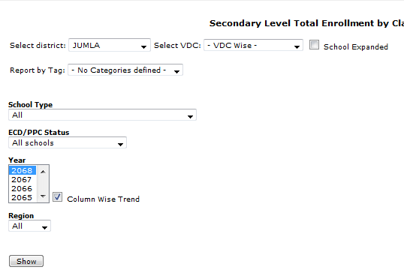

1. lhNnf / uflj;ut tYofFs afx]s olb >f]ts]Gb«ut jf lgjf{rg If]qut Reports x]g'{k/]df eg] ;a}eGbf klxn] Flash Software df uP/ Tags agfpg] / Report by Tags: df uP/ cfkm"n] agfPsf] Tags nfO{ Select u/]/ Show df Click ug]{ . Tags agfpg] t/Lsf k]h g+= ===== df lbOPsf] 5 .
2. Reports x? x]bf{ ljBfnosf] k|sf/, afnljsf; eP÷gePsf], jf ;'ud÷b'u{d cg';f/ x]g'{kg]{ ePdf School Type, ECD/PPC Status / Region df uP/ cfkm'nfO{ s] rflxPsf] xf] ;f] 5fGg] / Show df Click ug]{ .
3. o:t} u/L Year sf] xsdf klg cfkm"nfO{ s'g rflxF Year sf] Reports rflxPsf] xf] ;f] 5fGg] . Year df eg] PseGbf a9L Year x? klg 5fGg ;lsG5 . o;sf nflu Keyboard df Shift lyRg] / Year Click ub}{ hfg] . Year ;Fu} Column Wise Trend df Tick klg nfu]sf] 5 . ;f] Tick nfO{ oyfjt /fVbf / 2068, 2067 select ubf{ k|To]s Reports x?df 2068, 2067 sf Reports x? b]lvG5g\ . o;af6 Pp6} Report df w]/} jif{sf] Reports x]g{ ;lsG5 .

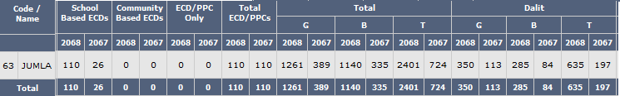

Year ;Fu} Column Wise Trend df nfu]sf] Tick x6fpFbf / 2068, 2067 select ubf{ klg k|To]s Reports x?df 2068, 2067 sf Reports x? b]lvG5g\ .

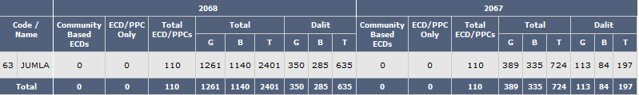

km/s olt dfq} xf] ls dfly b]vfOPsf] Reports df ;a}eGbf klxn] 2068 / To;kl5 2067 sf] Reports x? b]lvG5 .

1. Flash Software df /flvPsf cGo Rports x? h:t} District Report Card jf School Report Card jf cGo s'g} Reports x? x]g'{k/]df dfly elgP h:t} u/L cfkm"nfO{ rflxPsf] Reports x?nfO{ lhNnf, uflj;, uflj; / ljBfno jf Tags cg';f/ x]g{ ;lsg]5 .

**Flash Software df Data Import, Export / Maintenance ug]{ t/Lsf .**

1. lhNnfsf] Database nfO{ cfkm\gf] Computer df xfNg'kg]{ ePdf Import ug]{ . cfkm\gf] Computer af6 Data lgsfNg' k/]df Export ug]{ . Database nfO{ Repair ug{ jf Database df ePsf] Duplicates x6fpg jf Database g} x6fpg' k/]df Maintenance df ePsf] Repair, Duplicates / Remove Districts df Click ug]{ .
2. lhNnfsf] Database Import gul/sg Data Entry ug{ jf Reports x]g{ g;lsg] ePsf]n] Flash Software xfNg] ljlQs} Data Import ug'{kb{5 . Data Import ug]{ t/Lsf k]h g+= ===== df lbOPsf] 5 . Flash, TMIS, / Achievement ;a}sf] Data Import ug]{ tl/sf Pp6} xf] . olb Flash, TMIS jf Achievement Data Ps eGbf a9L Computer df Entry u/]sf] 5 eg] Tof] ;a} Data nfO{ Merge ug]{ t/Lsf klg Data Import g} xf] . Import ul/;s]kl5 Flash Software n] cfkm} Duplicate Data x6fpFb5 / ;a} Data Merge ul/lbG5 . ofb ug'{kg]{ s'/f] s] xf] eg] Data nfO{ hltrf]l6 Import u/]klg Data Delete eg] x'b}g .
3. lhNnfsf] Flash Data / TMIS Data Export ug'{k/] Export df Mouse sf] Cursor /fVg] / Flash & TMIS df Click ug]{ . olt ul/;s]kl5 This Year jf All Years s] rflxF ug]{ xf] ;f] Select ug]{ / Flash I jf Flash II jf TMIS x?dWo] s'g s'g Export ug]{ xf] ;f]xL cg';f/ Tick nufpg] / Export df Click ug]{ . Photo ;d]t Export ug'{k/]df eg] Include Photos df Tick nufpg] / Export df Click ug]{ . This Year Select u/]/ Data Export ubf{ Flash Software df s'g rflxF Year Set u/]sf] 5 ;f]xL jif{sf] Data x? Export x'G5 . pbfx/0fsf] nflu Flash Software df 2068/2069 Set u/]sf] 5 eg] This Year sf] Flash I Export ubf{ 2069 sf] / Flash II Select ubf{ 2068 sf] Data Export x'G5 . TMIS sf] Export klg o;}u/L x'G5 . All Years Select ubf{ eg] Computer df ePsf] ;a} Data x? Export x'G5 . o;/L Export u/]sf] Data Desktop df uP/ a:b5 .
4. cfkm"n] agfPsf] Tag nfO{ Export ug'{k/]df Export df uP/ Mouse sf] Cursor /fVg] / Tag df Click ul/lbg] . o;/L Export u/]sf] Data Desktop df uP/ a:b5 . o:t} u/L Achievement sf] Data Export ug'{k/]df Achievement df Click ul/lbg] . Tags agfpg] t/Lsf k]h g+= ===== df lbOPsf] 5 .
5. Database eGg] Section df Maintenance 5 h;leq Repair, Duplicates, / Remove Districts eGg] tLgj6f Buttons x? 5g\ . Database nfO{ lju|gaf6 arfpg jf lju|]sf] cj:yfdf agfpg'k/]df Repair df Click ug]{ / kfn}kfnf] Quick, Normal / Extended eGg] Button nfO{ Select ub}{ Repair ug]{ .

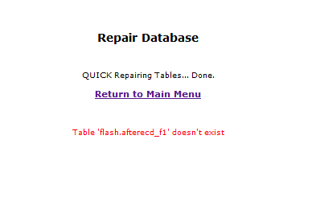

Database Repair ta;Dd ul//fVg] ha;Dd dfly b]vfOPsf] /ftf] cIf/ k"0f{?kdf x6\b}g . /ftf] cIf/ x6]df Database Repair eof] eGg] ;Dem] x'G5 . hlt Repair u/]klg /ftf] cIf/ gx6]df eg] ;DalGwt lj1;Fu hfgsf/L lng'kg]{x'G5 . Database gljlu|of]; eGgsf nflu Flash Software vf]Ng] ljlQs} Database Repair ul/lbG5 . ;f] cj:yfdf klg olb o:t} /ftf] cIf/x? cfPdf dfly elgP h:t} Repair ug]{ .

1. Reports df olb Duplicates b]lvPdf Maintenance df uP/ Duplicates Click ubf{ Database df ePsf] Duplicates x? x6\b5g\ . x'gt Database Import ug]{ ljlQs} Flash Software n] Duplicates x? cfkm} x6fpFb5 t/ sxLFst} Duplicates x? b]lvPdf Maintenance df uP/ Duplictes x6fpg ;lsG5 .
2. Flash Software af6 Database x6fpg'k/]df Maintenance df uP/ Remove Districts Click ug{ ;lsG5 . o;sf nflu Remove Districts df Click ug]{, cfkm\gf] lhNnfsf] gfd Select ug]{ / Remove df Click ug]{ . o;af6 Flash / TMIS sf] Data Remove x'G5 . Database lau|]df jf e}/x]sf] Database x6fP/ csf]{ xfNg'k/]df Remove Districts ug{ ;lsG5 .

**Flash Software df uflj; / ljBfnosf] gfd ;Rofpg], cfkm"n] rfx]sf] h:tf] Reports lgsfNg Tags agfpg], / Pp6f ljBfnosf] Data csf]{ ljBfnodf Entry ePdf ;Rofpg] t/Lsf .**

1. Database df ePsf] ljBfnosf] gfd jf uflj;sf] gfd ;Rofpg'k/]df Utilities Section sf] Rename df hfg] . Tags agfpg'k/]df Tags df hfg] . ljBfnosf] Data x6fpg'k/]df jf Pp6f ljBfnosf] Data csf]{df Entry ePsf] cj:yfdf Data Transfer ug'{ k/] School df hfg] .
2. ljBfnosf] jf uflj;sf] gfd ;Rofpg Rename df uP/ Mouse sf] Cursor /fVg] / ljBfno cyjf uflj; s:sf] gfd ;Rofpg rfx]sf] xf] ;f]xL cg';f/ Click ug]{ . ljBfnosf] gfd ;Rofpg eg] Flash I e/]sf ljBfnox?n] dfq kfpFb5g\ . o;sf nflu lhNnf Select ug]{, uflj;sf] gfd Select ug]{ / ljBfnosf] gfd Select ug]{ . olt ul/;s]kl5 ljBfnosf] gfd s] /fVg] xf] ;f] s'/f Edit eg]sf] 7fpFdf n]Vg] . o;/L gfd n]Vbf ljBfnosf] sf]8 eg] n]lv/fVg'kb}{g .

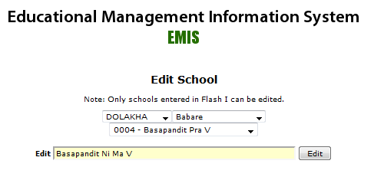

ljBfnosf] gfd ;RofFpbf hlt;s] Tolt ljBfnosf] gfd 5f]6f] /fVbf /fd|f] x'G5 . nfdf] gfd /fVbf Reports df ljBfnosf] gfd nfdf] b]lvg] x'Fbf 5f]6f] gfd /fVg' eg]sf] xf] . To:t} ljBfnosf] gfd ;Fu} ljBfnosf] tx /fVbf k|fylds xf] eg] Pra V, lgDg dfWoflds xf] eg] Ni Ma M, dfWoflds xf] eg] Ma V / pRr dfWoflds xf] eg] Uchha Ma V /fVg] . afnlasf; dfq rn]sf] xf] eg] afnljsf; s]Gb«sf] gfd ;Fu} Bbk n]Vg] .

1. Reports df h;/L lhNnf Select ubf{ lhNnfsf] / uflj; Select ubf{ uflj;sf] Report cfpFb5, To;}u/L Tags agfof] eg] ;f]xL cg';f/sf] l/kf]6{ x]g{ ldNb5 . pbfx/0fsf] nflu ABC eGg] Tag df Resource Center 1 leq A, B, C, D eGg] uflj;x? 5g\ eg]/ agfOof] eg] h;/L lhNnf tyf uflj;sf] l/kf]6{ x]bf{ ;f]xL cg';f/sf] Report b]lvG5, ca Tags af6 l/kf]6{ x]bf{ klg clw agfPsf] Resource Center 1 eGg] h:t} u/L >f]ts]Gb« cg';f/sf] l/kf]6{ x]g{ ;lsG5 .
2. Flash Software df Tags agfpg ;a}eGbf klxn] Utilities df Tags Click ug]{ . Category n]v]sf] 7fpFdf olb klxn] g} Tag agfOPsf] 5 eg] Tags sf List x? b]lvG5g\ . klxnf] rf]l6 xf] eg] Tag Category eGg] b]lvG5 . o:tf] cj:yfdf Or Add New n]v]sf] 7fpFdf s] Tag agfpg vf]h]sf] xf] ;f] gfd n]Vg] . pbfx/0fsf] nflu >f]ts]Gb« cg';f/ Tag agfpg nfu]sf] xf] eg] ;f] 7fpFdf Resource Center egL n]Vg] . Tag Name n]v]sf] 7fpFdf >f]ts]Gb«sf] gfd n]Vg], h:t} ABC . olt ul/;s]kl5 Add Tag df Click ug]{ .

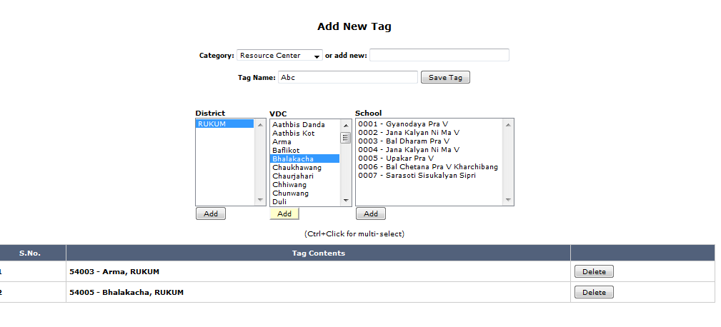

Save Tag df Click ul/;s]kl5 lhNnfsf] gfd Select ug]{, To;kl5 uflj;sf] gfd cfpFb5 / dfly elgPsf] ABC eGg] >f]ts]Gb«df s'g s'g uflj; kb{5g\ ;f] ;f] uflj;x? 5fGb} Add df Click ub}{ hfg] . s'g} uflj; jf gu/kflnsf Ps eGbf a9L >f]ts]Gb«df kb{5g\ eg] To:tf] cj:yfdf rflxF ljBfnox?nfO{ >f]ts]Gb« cg';f/ Add ub}{ hfg] . uflj; jf ljBfno xfNbf sxLF st} uNtL ePdf dfly b]lvPsf] Delete df Click ul/lbg] . Add ul/;s]kl5 Save Tag df Click ug]{ .

1. Psrf]l6 Resource Center eg]/ Category agfO;s]kl5 csf]{ >f]ts]Gb« agfpg'kbf{ Add New df uP/ Resource Center n]lv/fVg'kb}{g . o;sf nflu Category df hfg] / Resource Center Click ug]{, Tag Name: df hfg] / csf]{ >f]ts]Gb«sf] gfd n]Vg] / dfly elgP h:t} u/L Add Tag ug]{ . ca lhNnfsf] gfd Select ug]{ / ;f] >f]ts]Gb«df s'g s'g uflj;x? kb{5g\ ;f]xL cg';f/ uflj;x? Select ug]{ / Add ub}{ hfg] . ljBfnox? Add ug'{kg]{ cj:yf cfPdf VDC Select ul/;s]kl5 ljBfnox? Select ub}{ Add ub}{ hfg] . ;a} Add ul/;s]kl5 Save Tag df Click ug]{ . of] k|lqmof ta;Dd ul//fVg] ha;Dd lhNnfsf] ;a} >f]ts]Gb«x?sf] Tag aGb}g .
2. s'g} ljBfnosf] Data x6fpg k/]df Utillities sf] School eGg] Section df /x]sf] Remove af6 ;f] sfd ug{ ;lsG5 . o;sf nflu Remove df Click ug]{ / h'grflxF ljBfnosf] Data x6fpg] xf] ;f] ljBfnosf] School Code xfNg] . Flash I sf] Data x6fpg'k/] Flash I Select ug]{, Flash II sf] Data x6fpg'k/] Flash II Select ug]{ . x'gt ljBfnosf] Data x6fpg'kg]{ cfjZostf vf;} x'b}g, x6fpg' g} k/]df Transfer -tn lbOPsf]_ ug{ ;lsG5 . t/ Flash Software af6 ljBfno aGb ubf{ jf ljBfnonfO{ Merge ubf{ uNtL eof] eg] Remove af6 ;f] uNtL x6fpg ;lsG5 . pbfx/0fsf] nflu A eGg] ljBfno aGb eof] / ;f] ljBfnonfO{ Flash I df uP/ Close ul/of], t/ kl5 yfxf eof] ls ;f] ljBfno aGb ePsf] /x]g5, o:tf] cj:yfdf Remove df uP/ ;f] ljBfnosf] sf]8 g+= xfn]/ Remove ul/lbof] eg] ljBfno aGb x'Fbf h;/L ljBfnosf] gfd sfl6P/ cfpFb5, ;f] x6fpg ;lsG5 . ljBfno Merge ubf{ olb uNtL ePsf] cj:yf xf] eg] klg o;} u/L ;f] uNtL ;Rofpg ;lsG5 .
3. Pp6f ljBfnosf] Data csf]{ ljBfnodf Entry x'g uPdf Utilities sf] School eGg] Section df /x]sf] Transfer af6 Data ldnfpg ;lsG5 . pbfx/0fsf] nflu A eGg] ljBfnosf] Data B eGg] ljBfnodf Entry ePsf] 5 / ca ;f] Data A df g} Nofpg'k/]df Transfer df Click ug]{ / School1: n]v]sf] 7fpFdf B sf] ljBfno sf]8 n]lvlbg], School2: n]v]sf] 7fpFdf A sf] ljBfno sf]8 n]lvlbg] / Flash I jf Flash II s'g rflxFsf] Transfer ug]{ xf] ;f] Select u/]/ School1 - > School 2 df Click ul/lbg] . o;/L Click ubf{ Are You Sure You Want To Transfer? eG5, OK df Click ul/lbg] .

**Flash Software ;Fu ;DalGwt s]xL ;d:ofx? .**

1. Flash Software xfln;lsof] t/ vf]Nbf v]l/ rn]g <

o;sf ljljw sf/0fx? x'G5g\ . oxL sf/0fn] g} Flash Software grn]sf] xf] eg]/ eGg rflxF ufXf] x'G5 . o;}sf/0f tn lbOPsf sf/0fx? / ;f] ;Fu ;DalGwt pkfox? ckgfpb} uPdf Flash Software gvf]lng] ;d:of x6\g ;Sb5 .

**sf/0f g+= !M sDKo"6/df Virus nfu]sf] 5 / ;f] Virus n] Internet ;Fu ;DalGwt s'g} klg Internet Browser vf]Ng lbb}g .**

Flash Software klg Internet Browser -h:t} Internet Explorer, Mozilla Firefox_ df vf]lng] x'Fbf sltko Viruses x?n] Internet Browser vf]Ng glbFbf Flash Sotware gvf]lnPsf] xf] . Internet Broser rnfpg lbOPg eg] Computer df Virus x6fpg] Software xfNg g;lsg] x'Fbf sltko Virus n] Internet Broser rnfpg /f]lslbG5 .

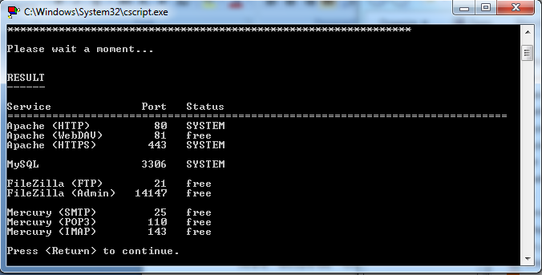

Flash Software Install ug]{ a]nfdf dfly b]vfOPsf] h:tf] Boxes x? cfpF5g\ / hfG5g\ . olb Computer df Virus nfu]sf] 5 / ;f] Virus n] Flash Software ;Fu ;DalGwt Browser, jf Database /f]lslbPsf] 5 eg] o:tf] vfn] Boxes x? cfpFb} cfpFb}gg\ . o;}sf/0f of] ;d:of cfPdf ls t Computer af6 Virus k'/} x6fP/ dfq Flash Software xfNg ;lsG5 ls t Computer k'/} Format u/]/ dfq} .

**sf/0f g+= @M Flash Software xfNbf Block/Unblock jf Allow/Don't Allow h:tf s'/fx? ;f]Wbf Block jf Don't Allow df Click ul/lbFbf Flash Software grn]sf] .**

Flash Software xfNbf Computer sf] Operating System -h:t} Windows XP, Windows 7_ cg';f/ Block/Unblock jf Allow/Don't Allow h:tf s'/fx? ;f]Wb5g\ . o:tf] cj:yfdf olb Block jf Don't Allow h:tf Buttons x?df Click ul/lbFbf Flash Sotware ;Fu ;DalGwt Files x? Install x'g kfpb}gg\ / Flash Sotware rNb}g . o:tf] xf] eg] Flash Software nfO{ Uninstall u/]/ km]l/ Install ubf{ Unblock jf Allow ul/lbof] eg] Flash Software v'Nb5 . Flash Software nfO{ Uninstall ug]{ t/Lsf k]h g+= ===== df lbOPsf] 5 .

**sf/0f g+= #M Flash Software xfNbf Unblock jf Allow ubf{ klg Flash Software grn]sf] .**

olb sf/0f g+= ! df elgP h:t} Boxes x? klg cfpFb5, Unblock jf Allow u/]sf] 5 / klg Flash Software rn]sf] 5}g eg] ;DejtM Flash Software ;Fu ;DalGwt Apache / Mysql dWo] s'g} Ps jf b'j} kmfOnx? Run ePsf 5}gg\ . o;sf nflu Computer sf] Start jf Windows Icon df hfg], Run jf Search Programs And Files df hfg] / Services.msc n]Vg] / Enter df Click ul/lbg] .

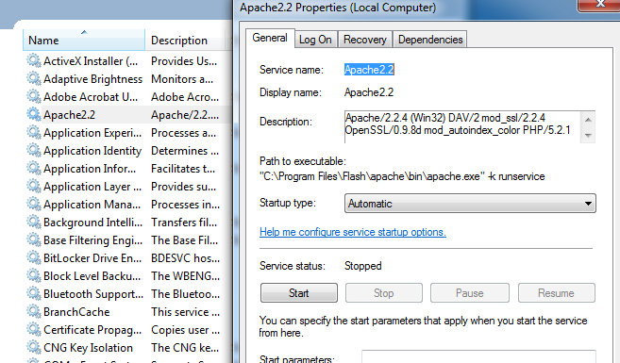

dfly b]lvPsf] afFofkl§sf] Box df Apache 2.2 df Click ul/;s]kl5 olb Computer df Apache grn]sf] xf] eg] bfoFfkl§ b]lvPsf] Start eGg] Button Active x'G5 . o:tf] cj:yfdf Start df Click ul/lbg] . Start df Click ul/;s]kl5 Start Button wldnf] x'G5 / Stop Button Active b]lvG5 . olb Start ubf{ Error cfPdf Computer nfO{ Restart ug]{ / km]l/ oxL k|lqmof bf]xf]–ofpg] .

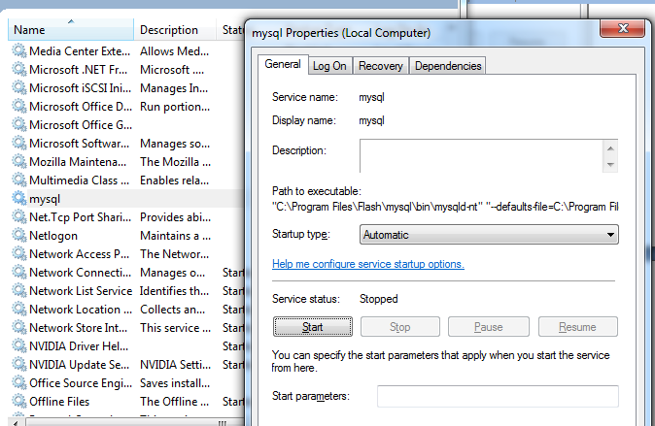

Apache nfO{ Start u/fO{;s]kl5 Mysql klg rn]sf] 5, 5}g x]g]{ . To;sf nflu clw h:t} Services.msc df hfg] / Mysql nfO{ Click ug]{ . ca Start df Click ul/lbg] . Mysql rln;s]kl5 Start eGg] Button wldnf] x'G5 / Stop eGg] Button Active x'G5 . olb Start ubf{ Error cfPdf Computer nfO{ Restart ug]{ / km]l/ oxL k|lqmof bf]xf]–ofpg] . olt ul/;s]kl5 Flash Software ;DejtM v'Nb5 .

**sf/0f g+= $M MySql rln/x]sf] 5 t/ Apache2.2 eg] hlt ubf{ klg rNb}g .**

o;sf b'O{ sf/0fx? 5g\ . !_ Computer df s'g} sf/0fjz Apache.exe eGg] File g} 5}g . o;sf nflu C Drive df Program Files df Flash leq Apache leq Bin eGg] Folder leq Apache n]v]sf] Exe File 5 ls 5}g x]g]{ . olb 5}g eg] Flash Software rln/x]sf] Computer df hfg] / dfly elgPsf] 7fpFaf6 Apache.exe skL u/]/ Nofpg] / h'g Computer df xfNg'kg]{ xf] ;f]df Paste ul/lbg] . @_ Flash Software n] Apache nfO{ h'g Port sfod ul/lbPsf] x'G5, ;f] Port cGo s'g} Software n] k|of]u ul//x]sf] 5 . pbfx/0fsf] nflu Flash Software n] Port 80 lnPsf] x'G5 / csf]{ Software h:t} Skype n] klg ;f]xL Port k|of]u ub{5 . cyf{t\ Flash Software rnfpFbf Skype klg rnfpg ;lsb}g . Flash Software sf] Apache n] k|of]u ug]{ Port cGo s'g} Software n] lnPsf] 5 ls 5}g eg]/ kQf nufpg C drive sf] Program Files sf] Flash leq Xampp-portcheck eGg] File Open ug]{, Yes / No eg]/ ;f]Wbf Yes ug]{ / tn b]vfOPsf] h:tf] Pp6f Screen cfpFb5 .

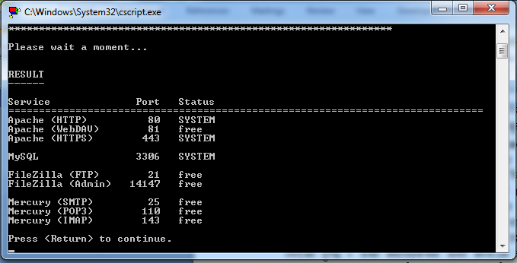

dfly lbOPsf] Box df Apache <HTTP> n]v]sf] 7fpFdf Port 80 lbOPsf] 5 h'g Flash Software sf] nflu l7s 5 . t/ olb Port 80 cGo s'g} Software n] lnPsf] 5 -h:t} Skype, Xampp, Trend Micro_ eg];f] cj:yfdf tL Software x?nfO{ Disable u/]/ jf Uninstall ug]{ / Apache Start u/]/ Flash Software rnfpg ;lsG5 . Apache nfO{ Start u/fpg] t/Lsf k]h g+= ===== df lbOPsf] 5 .

**sf/0f g+= %M Administrator df Install ug'{kg]{ Flash Software User df Install ePsf] x'g'kb{5 .**

x'gt User df Flash Software Install eP/ vf;} ;d:of x'b}g . t/ User nfO{ vf;} s'g} ;'ljwf lbOPsf] 5}g -h:t} Software xfNg], Software xfn] klg sltko s'/fx? Install x'g glbg], cflb_ eg] o:tf] cj:yfdf Flash Software rNb}g . o;f] x'Fbf ls t Flash Software nfO{ Administrator df of t User sf] ;'ljwf a9fP/ Install ug{ ;lsG5 .

**sf/0f g+= ^M Apache / Mysql b'j} rn]sf] 5 t/ klg Flash Software vf]Nbf Pp6f uf]nf] Icon w'ld/xG5 / s]xL klg x'b}g .**

of] ;d:of cS;/ Trend Micro Client gfds Software n] NofpFb5 . of] Software nfO{ Uninstall klg ug{ ldNb}g . o;}sf/0f Start df Run jf Search Program And Files df uP/ Msconfig 6fOk ug]{ / Enter ug]{ .

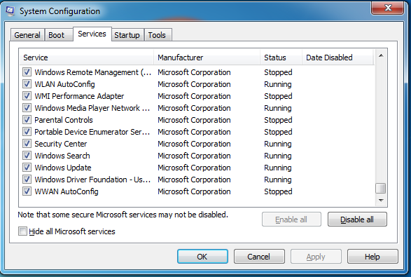

dfly b]lvPsf] h:tf] Box cfPkl5 Services df Click ug]{ / Trend Micro eGg] Service x]b}{ hfg] . tL zJbsf hlt Services x? b]lvG5g\ ;f]sf] Tick x6fpg] / Apply df Click ug]{ . olt ul/;s]kl5 OK df Click ug]{ / Computer Restart ug]{ . ca ;DejtM Flash Software v'Nb5 .

1. Flash Software rln/fv]sf] lyof] t/ s'g} sf/0faz clxn] rNb}g <

o;sf nflu ;j{k|yd Computer df s;}n] Flash Software x6fPsf] 5 ls 5}g eg]/ kQf nufpg] . o;f] ug{ C Drive sf] Program Files sf] Flash eGg] Folder vf]Ng] . Computer af6 Flash Software x6fOPsf] xf] eg] ;f] Folder leq #,$ j6f hlt dfq Files/Folder x? x'G5g\, x}g eg] w]/} x'G5g\ . olb x6fOPsf] xf] eg] Flash Software km]l/ xfNg] afx]s ljsNk 5|}g . olb x6fOPsf] 5}g eg] ! g+= a'Fbfdf elgPsf ;a} sfdx? ug]{ .

**sf/0f g+= !M a'Fbf g+= ! df elgPsf] h:tf] ;a} ul/of] cem} klg rn]g .**

Flash Software h'g k]hdf cfpFb5, ;f] k]h olb kl/jt{g ul/of] eg] klg Flash Software rNb}g . o;sf nflu Flash Software vf]Ng] / dflykl§ <http://localhost/flash/index> n]v]sf] 5 ls 5}g x]g]{ . 5}g eg] ;f] address n]lvlbg] . To:t} Keyboard af6 Alt / F lyRg] / Pp6f Menu cfpFb5, ;f] Menu df Work Offline df Tick nfu]sf] 5 ls 5}g x]g]{ . nfu]sf] 5 eg] Tick x6fOlbg] . olt ul/;s]kl5 Flash Software ;DejtM v'Nb5 . olt ubf{ klg v'n]g eg] ;DalGwt lj1;Fu hfgsf/L lng] .

1. Flash Software sf] k]h kl/jt{g eP5, k|To]s rf]l6 Software vf]Nbf ;f] k]h 6fOk ul//fVg'kg]{ eof] <

o;sf nflu Flash Software vf]Ng] . Alt / T Click ug]{ / Options df hfg] . olt ul/;s]kl5 tn b]vfOP cg';f/sf] Box cfpFb5 .

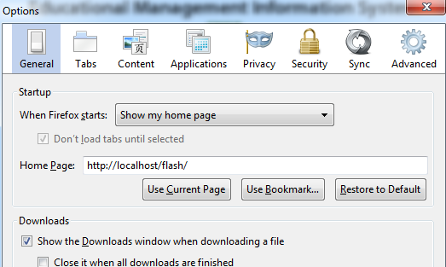

General df Click ug]{ / Home Page: n]v]sf] 7fpFdf dfly n]lvPsf] Address Type ug]{ . olt ul/;s]kl5 k|To]s rf]l6 Flash Software vf]Nbf Flash sf] k]h vf]lnG5 .

1. aQL emofK\k uP/ rln/fv]sf] Flash Software rNg 5f8\of] <

o;sf nflu ;a}eGbf klxn] My Computer sf] C Drive df hfg] . C Drive df Mouse n] Right Click ug]{ / Properties df Click ug]{ . ca Tools df Click ug]{ / Error-Checking df Check Now df Click ug]{ . ca Pp6f Box cfpFb5 . Tof] Box df Automatically Fix File System Errors df Click ug]{ / Start df Click ul/lbg] .

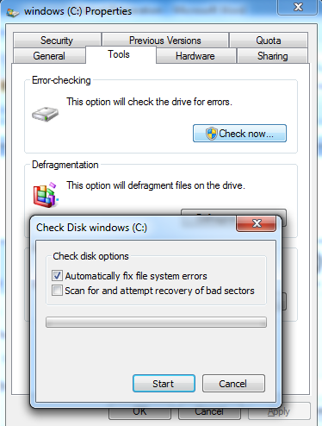

olt ul/;s]kl5 Yes jf No eg]/ ;f]Wb5 . Yes df Click ul/lbg] . ca Computer nfO{ Restart ul/lbg] . Restart ul/;s]kl5 Computer nfO{ Scan ug{ lbg] . Scan ;lsPkl5 Flash Software vf]Ng], ;DejtM v'Nb5 . vf]n]g eg] a'Fbf g+= ! / @ df elgPsf ;a} sfo{x? ug]{ .

1. tn b]vfOPsf] lrqx?df 2068/2069 sfnf] /Ëdf / 2067/2068 /ftf] /Ëdf lsg b]lvPsf] xf] <



Flash Software df /flvPsf] ldlt Computer sf] ldlt;Fu hf]l8Psf] 5 . o;}sf/0f Computer df ePsf] ldlt;Fu Flash Software sf] ldlt ldNof] eg] sfnf] b]lvG5, gq /ftf] . pbfx/0fsf] nflu xfnsf] ldlt 8/27/2012 5 eg] Flash Software sf] ldlt 2068/2069 x'g}kb{5, lsgeg] xfnsf] o; ldltdf 2068 sf] Flash II / 2069 sf] Flash I eg]{ g} xf] . ;f] afx]s cGo ldlt xfNbf uNtL ePsf] xf] ls eg]/ b]vfOPsf] xf] . olb uNtL ePsf] xf] eg] Flash Software vf]ln;s]kl5 Main Menu df hfg] / Set Year df uP/ ;xL Date xfNg] .

1. Flash Software sf] ;d:of /fVbf Pp6f kmfOn E-mail df kfOof] / ;f] kmfOnnfO{ c:\Program files\Flash\htdocs\flash df nu]/ Paste ul/lbg'; elgof], s] ug]{ <

Computer sf] efifdf C:\ eGgfn] C Drive leq eGg] a'emfpFb5, o;}sf/0f c:\Program files\Flash\htdocs\flash eGgfn] C Drive leq Program Files leq Flash leq htdocs leq Flash eGg] Folder df Paste ul/lbg'; eg]/ eg]sf] xf] .

1. Flash Software /fv]sf] Computer s'g} sf/0fjz ljlu|of], Database klg st} /fv]sf] lyPg, s'g} pkfo4f/f ;f] Data Nofpg ;lsG5 ls <

Computer sf] Harddisk olb ljlu|Psf] 5}g eg] To:tf] cj:yfdf ;f] Computer sf] Harddisk csf]{ Computer df /fv]/ jf DOS Prompt df uP/ Flash Software sf] Data nfO{ ;'/lIft /fVg ;lsG5 . o;sf nflu ljlu|Psf] Computer sf] Hard Disk df C:\Program Files\Flash\mysql df hfg] / Data eGg] Folder nfO{ ;'/lIft ;fy /fVg] . of] Data nfO{ csf]{ Computer df /fVg'kg]{ xf] eg] Services.msc df uP/ Mysql Stop ul/lbg] . C:\Program Files\Flash\mysql df uP/ clw NofPsf] Data eGg] Folder nfO{ Paste ul/lbg] . Replace ug]{ eg]/ ;f]Wbf Yes elglbg] . Services.msc df Mysql nfO{ Start ul/lbg] . Services.msc df Mysql nfO{ Stop jf Start ug]{ t/Lsf k]h g+= ===== df lbOPsf] 5 . ca Computer df k'/fgf] Data ;a} cfpFb5 . t/ h'g Computer df clw NofPsf] Data xfn]sf] xf], ;f]df olb gofF Data x? 5g\ eg] tL Data x?rflxF x/fpFb5g\ . cfkm" ljZj:t gePdf lj1sf] ;xof]u lng] .

1. Flash Software nfO{ Uninstall s;/L ug]{ <

s'g} sf/0fjz Flash Software nfO{ Uninstall ug'{k/]df C:\Program Files\Flash df hfg] / Uninstall nfO{ Click ul/lbg] . ca Allow ug]{ ls gug]{ eg]/ ;f]Wb5, Yes ug]{ . olt ul/;s]kl5 Uninstall nfO{ Click ul/lbg] . Uninstall ul/;s]kl5 C:\Program Files sf] Flash Folder nfO{ klg Delete ul/lbg] . Delete x'g dfg]g eg] Computer Restart u/]/ eP klg Remove ul/lbg] . of] Folder nfO{ Remove gul/sg km]l/ Flash Software xfNg vf]h]df slxn] sfFxL ;d:of cfpg ;Sb5 .

1. Flash Software v'Nb5 t/ Entry ug{ nfUbf lhNnfsf] jf uflj;sf] jf ljBfnosf] gfd g} cfpFb}g <

olb Flash Software df lhNnfsf] gfd jf uflj;sf] gfd g} cfpb}g eg] Data Import ug'{ePsf] 5}g eGg] yfxf x'G5 . o;sf nflu lhNnfsf] Database lng] / Import ul/lbg] . Import ug]{ t/Lsf k]h g+= ==== df lbOPsf] 5 . s'g} klg ljBfnosf] gfd cfPsf] 5}g eg] clw eg]sf] h:tf] u/L Import ul/of] eg] ljBfnosf] gfd cfpFb5 . Flash II sf] xsdf olb s'g} ljBfnox?sf] gfd cfPsf] 5}g eg] ;DejtM tL ljBfnox?n] Flash I e/]sf 5}gg\ . ofg] s'g} jif{sf] Flash I e/]sf] 5}g eg] ;f] ljBfnosf] Flash II eg{ ;lsb}g . o;sf nflu ;f] ljBfnosf] Flash I eg]{ / km]/L Flash II df hfg], ca ljBfnosf] gfd cfpFb5 .

1. Flash Software v'Nb5, lhNnf tyf uflj;sf] gfd klg b]lvG5, ljBfnosf] gfd klg 5 t/ hlt ljBfnox? x'g'kg]{ xf] ;f] gfdx? b]lvb}g . klxn]sf jif{x?df ljBfnox?sf] gfd ;a} b]lvGYof], s] ePsf] xf] <

of] k|Zgsf] pQ/ yfxf kfpg'k"j{ ljBfnosf] gfd Flash Software df s;/L cfpFb5 eGg] s'/f hfGg' clt cfjZos 5 . Flash I sf] xsdf xf] eg] ljBfnosf] gfd tkfO{sf] Database ;Fu ;DalGwt 5 . olb Computer df 2062 b]lv 2068 ;Ddsf] ;a} Database /fv]sf] 5 eg] ;a} ljBfnox?sf] gfd b]lvG5 . olb dfgf}+ 2068 sf] dfq} /flvPsf] 5 eg] ;f] ;fndf Flash I df Entry ePsf ljBfnox?sf] dfq gfd b]lvG5 . o:tf] cj:yfdf ;a} jif{sf] Data Import ul/lbof] eg] Flash I df ;a} ljBfnosf] gfd b]lvG5 . Flash II sf] xsdf eg] Flash I e/]sf] ljBfnox?sf] dfq gfdgfd];L b]lvG5 . cfkm\gf] Computer df k'/fgf] Database 5 ls 5}g eg]/ yfxf kfpg s'g} klg Reports df hfg] / clwNnf] jif{x?sf] Report x]g]{, olb cfpFb5 eg] Computer df k'/fgf] Database 5, gq 5}g .

1. Flash sf] Data b'O{ eGbf a9L Computer df Entry ul/Psf] lyof], s;/L Ps} 7fpFdf Merge ug]{ xf] <

;a} Computer df Entry u/]sf] Flash sf] Data nfO{ Copy u/]/ h'g Computer df Merge ug]{ xf] ;f] Computer df Nofpg] / kfn}kfnf] Import ul/lbg] . Import ug]{ t/Lsf k]h g+= ==== df lbOPsf] 5 .

1. Import w]/} ubf{ Data x/fpg ;S5 ls ;Sb}g <

hlt rf]l6 Import u/]klg Data x/fpb}g . a? sxLF st} Data 5'6]km'6]sf 5g\ eg] ldnfO{lbG5 . t/ Import ubf{ eg] Computer sf] Date nfO{ ljz]if Wofg lbg'kb{5 . tn lbOPsf] Box af6 Computer sf] Date / Import sf] ;DaGw b]vfpFb5 .

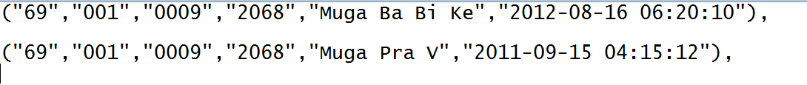

dflysf] Box df Import ul/;s]kl5 Flash Software n] s;/L Data Merge ub{5 eGg] s'/fsf] hfgsf/L lbG5 . Computer df Merge ubf{ Data x? dfly b]vfPsf] cg';f/ a:b5g\ . ToxfF Pp6} ljBfno sf]8 ePsf] b'O{ j6f ljBfnox?sf] gfd 5 h;dWo] Pp6f ljBfnosf] gfd x6fpg'kg]{ x'G5 . ca dfgf}+ Muga Pra V eGg] gfd ;xL 5 t/ Computer sf] Date unt 5 / 2011-09-15 cfPsf] 5 . Flash Software n] Import / Merge ubf{ ;a}eGbf clGtd ldlt x]b{5 / Tof] eg]sf 2012-08-16 xf] . To;}n] olb Muga Pra V eGg] ;xL tYofFs xf] eg] klg Merge ubf{ / Duplicate x6fpFbf Muga Pra V nfO{ x6fpFb5 . o;}sf/0f Computer df ;xL Date x'g' clQ g} cfjZos 5 .

1. Import ubf{ tn b]vfOPsf] h:tf] Message lbG5, s] ePsf] xf] <

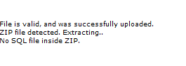

Database ;xL gePsf]n] o;f] ePsf] xf] .

1. Database Export ubf{ tn b]vfOPsf] h:tf] Message lbG5, s] ePsf] xf] <

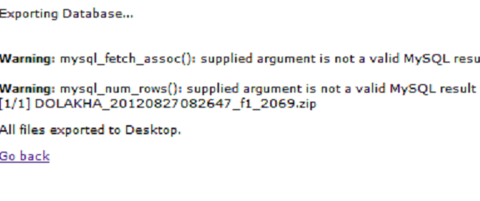

Flash Software df ePsf s'g} Ps jf ;f] eGbf a9L Tables x? ljlu|Pdf o:tf] ;d:of cfpFb5 . o;sf nflu Database Repair ug]{ / Export ug]{ . Database Repair ug]{ t/Lsf k]h g+= ==== df lbOPsf] 5 .

1. Flash Software df 2068/2069 /flvPsf] 5, Flash II df ljBfnox? gb]lvPsf]n] Flash I df uP/ tL ljBfnox? h:n] Flash I e/]sf lyPgg\ ltgLx?sf] klg Data Entry u/], t/ klg Flash II df ljBfnox?sf] gfd b]lvPg, lsg xf] <

Flash Software df 2068/2069 /flvPsf] 5 eg] To;sf] dfg] 2068 sf] Flash II / 2069 sf] Flash I x'G5 . Flash II df ljBfnosf] gfd b]lvPg eg] 2068 sf] Flash I Entry ug'{kg]{ x'G5 hals w]/}n] 2069 sf] Flash I Entry ub{5g\ . o;sf nflu Set Year df hfg] / 2067/2068 Set ug]{ / Flash I Select u/]/ Entry ug]{ . Entry ;ls;s]kl5 km]l/ Set Year u/]/ 2068/2069 ug]{ / Flash II df hfg] . olt ul/;s]kl5 ljBfnox?sf] gfd cfpFb5 .